# Week1

* 3 agents in economics – Producers (firms), Consumers (households), Government
* Economic activity comprises of 5 components – Production, Consumption, Exchange, Distribution and Investment.
* Production and Consumption is aided by Exchange. Exchange has an underlying Distribution (of resources). This causes investments, which in turn drives production.
* Investment can be thought of as consumption in time t+1.
* Study of economics at the scale of individual house-holds or firms is called micro-economics.
* Study of economics at aggregated at the level of an industry, state, country or at a global level is called macro-economics.
* Price (product) is a connector between micro and macro level of economics.
* Production is the process that converts raw materials into usable goods/services. It provides value-addition, and as a result has a utility value.
* Pricing co-ordinates decisions made by producers and consumers.

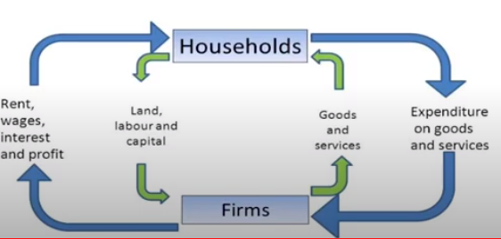.

* This diagram depicts the circular flow of income. Money flows in the outer circuit and resources flow in the inner circuit, in the opposite direction.
* Consumption basket is the collection of all items consumed by a household in a certain time period. This concept is used to determine the demand.
* Utility is a measure of the satisfaction received by a customer when a good or service is consumed. It’s a function of its price and customer’s income.
* Consumer’s choice is decided by income and utility of the goods/services.
* Large-scale surveys help firms in devising strategies and rightly positioning themselves in the market.
* Demand is created by consumption, not by production or any other activity.
* Utility can be measured either in cardinal (absolute units), or ordinal (relative) terms.
* Marginal utility is the additional utility obtained by the consumer for an additional unit of good/service.
* Marginal utility (MU) is computed as change in total utility divided by change in quantity **ΔTU/ΔQ**
* Consumer equilibrium is achieved when the ratio of the marginal utility and the price of the good/service is equal to that of another, 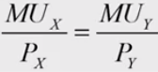
* Law of diminishing marginal utility states that as the quantity consumed goes up, the marginal utility derived from the good/service reduces.
* Indifference curves are plotted against two competing goods/services and indicates the marginal utility derived out of different consumption patterns of those. Thus, all points in a particular curve depicts different combinations of the two goods that gives the same marginal utility. Consumer, depending on his/her income, will attempt to move to higher indifference curves (higher utility).

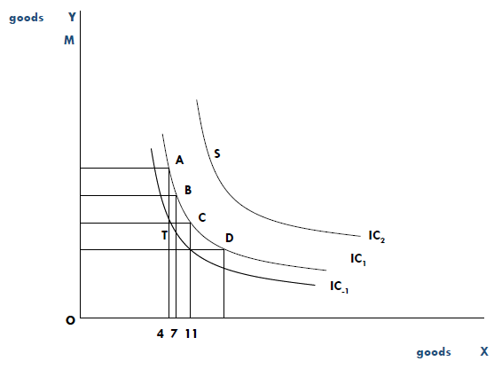

* Law of demand states that demand for a good/service falls with increasing price, given all other things are equal.
* Normal and inferior goods: Demand of normal goods increase with an increase in income, whereas demand for inferior goods decrease with an increase in the income.
* Substitutes and complements: Demand of substitute goods increase with an increase in price, whereas demand for complement goods decrease with an increase in the price.
* When price varies, demand moves along the demand curve. In all other cases (income, price of related goods, tastes, expectations, number of buyers), demand curve itself shifts. With an increased income, typically the demand increases for every price, Thus, in this case the demand curve shifts to the right.
* The price at which demand and supply curves intersect is called market clearing price. This is case of market equilibrium.

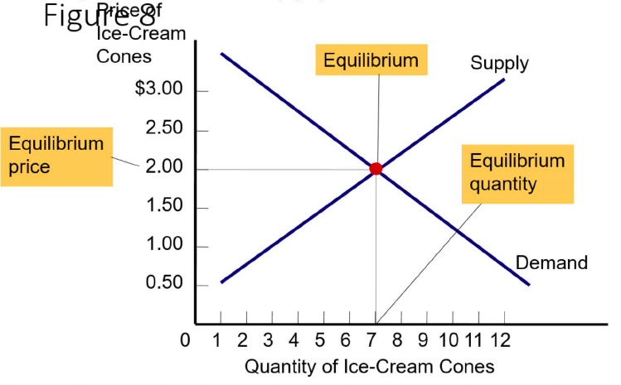

* When the demand is more (shortage), the price gets increased. When the supply is more(surplus), the price gets reduced. In either case, it results in a new market clearing price.

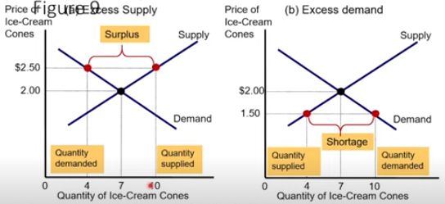

* Elasticity is the measure of responsiveness of quantity demanded or quantity supplied, to any one of its determinants (Price/income)
* Price elasticity measures the % change in demand effected by the % change in price. Calculated as (**ΔQ/Qprior)/(ΔP/Pprior)**
* Goods with close substitutes and luxury items are more price-elastic (demand falls with slight increase in price). Necessity items are less price-elastic.
* When the good is perfectly inelastic, the demand curve is vertical. When the good is perfectly elastic, the demand curve is horizontal.
* Income elasticity measures the % change in demand effected by the % change in income. Calculated as (**ΔQ/Qprior)/(ΔI/Iprior).**
* In the case of positive income elasticity, with increasing income, demand also increases. Reverse scenario occurs in the case of negative income elasticity.
* Normal goods have positive income elasticity. Inferior goods have negative income elasticity.
* Normal goods (+ necessities) typically have income elasticity between 0 and 1, and normal good (+ luxuries) have income elasticity greater than 1.
* In the case of cross-price income elasticity, raising price of one good increases demand for its substitutes, and reduces demand for its complements. It’s calculated as (**ΔQ1/Q1prior)/(ΔP2/P2 prior),** where ΔQ1 is the quantity of the first good, and ΔP2 is the price of the second good.
* Substitutes have cross-price (of the other good) elasticity greater than 0. Complements have cross-price (of the other good) elasticity less than 0.
* Elasticities work on the supply side, much the same way as the demand.
* Economists and accountants view business differently. While accountants consider all other than explicit costs as accounting profit, economists subdivide it into implicit costs and economic profit.
* Marginal product of labor keeps diminishing, a simple production environment. Thus, after adding the nth worker, the marginal product becomes 0.
* Marginal cost is given by the formula (**ΔC/ ΔQ),** where ΔC is the change in total cost and ΔQ is the change in quantity produced/sold.
* Typical curves of production

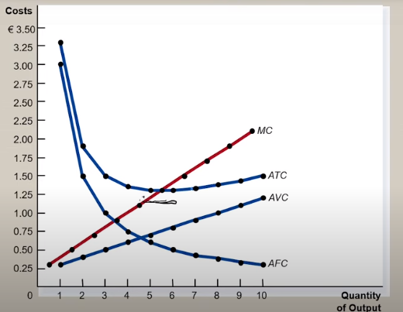

* Production should ideally be stopped when the Marginal cost crosses above average total cost.
* During the initial stages of production, Average Total Cost (ATC) reduces and this part is called economies of scale. See following graph.

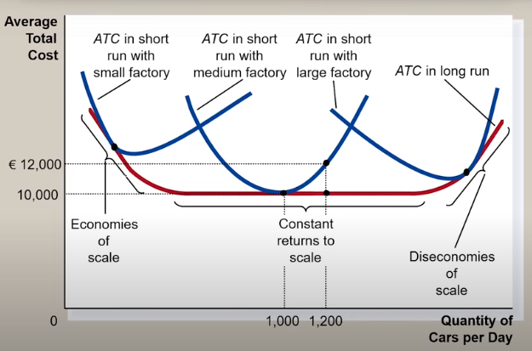

* Production function defines a relationship between inputs and the maximum amount that can be produced within a given period of time, with a given level of technology. It inputs include KLEM (Cost, Labor, Energy and Material) and produces maximum output.
* Marginal product (MP) = Change in output/Change in input - **ΔQ/ΔX**
* If MP > AP, then AP is rising. If MP < AP, then AP is reducing. Stop hiring when MP = AP.

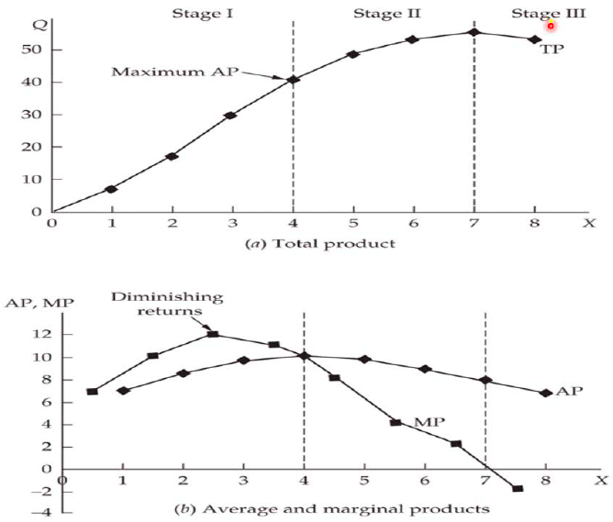

* Stop production when Marginal cost = Marginal revenue.

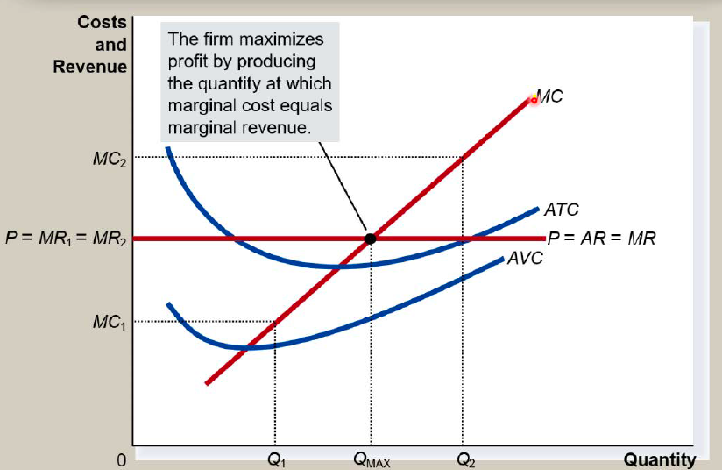

* It’s best to enter the market when P > ATC, and exit when P < ATC
* 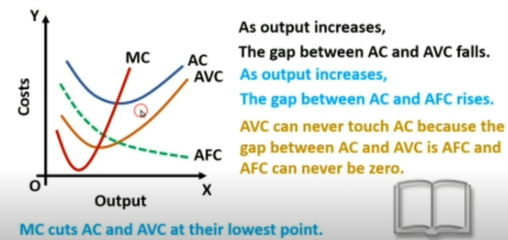
* When AC falls, AC > MC; When AC rises, AC < MC; When AC is minimum, AC = MC
* TC = TFC + TVC; ATC = AFC + AVC
* TC = AC * Q; TFC = AFC * Q; TVC = AVC * Q
* TVC = ∑MC; TVCold + MCnew = TVCnew; TCold + MCnew = TCnew

# Week-3

* [Pricing strategies](https://www.profitwell.com/recur/all/pricing-strategy-guide/)**:**
  + **Value-based pricing**

**With value-based pricing, you set your prices according to what consumers think your product is worth. SaaS businesses are typical examples.**

* + **Competitive pricing**

**When you use a competitive pricing strategy, you're setting your prices based on what the competition is charging. This can be a good strategy in the right circumstances, such as a business just starting out, but it doesn't leave a lot of room for growth.**

* + **Price skimming**

**Setting prices as high as the market will possibly tolerate and then lower them over time. The goal is to skim the top off the market and the lower prices to reach everyone else. With the right product it can work, but you should be very cautious using it**

* + **Cost-plus pricing**

**This is one of the simplest pricing strategies. You just take the product production cost and add a certain percentage to it. While simple, it is less than ideal for anything but physical products.**

* + **Penetration pricing**

**One way some companies attempt to push new products in highly competitive markets is by offering prices that are much lower than the competition. This is penetration pricing. While it may get you customers and decent sales volume, you'll need a lot of them and you'll need them to be very loyal to stick around when the price increases in the future.**

* + **Economy pricing**

**This strategy is popular in the commodity goods sector. The goal is to price a product cheaper than the competition and make the money back with increased volume. While it's a good method to get people to buy your generic soda, it's not a great fit for SaaS and subscription businesses.**

* + **Loss leader pricing**

**Loss leader pricing is a marketing strategy that involves selecting one or more retail products to be sold below cost – at a loss to the retailer – in order to get customers in the door. The loss leaders are the products being sold at such low prices as an enticement to buyers to step foot in the store**

* + **Marginal cost pricing**

**Marginal-cost pricing is the practice of setting the price of a product to equal the extra cost of producing an extra unit of output.**

* + **Absorption cost pricing**

**This is the method for setting prices, under which the price of a product includes all of the variable costs attributable to it, as well as a proportion of all fixed costs. ... The term includes the word "absorbed," because all costs are absorbed into the determination of the final price**

* Financial statements
  + Balance sheet
  + Income statement
  + Cashflow statement
  + Statement of retained earnings
* The [current ratio](https://corporatefinanceinstitute.com/resources/knowledge/finance/current-ratio-formula/) measures a company’s ability to pay off short-term liabilities with current assets: **Current ratio = Current assets / Current liabilities.** Ideal ratio – 1.5:1
* The [acid-test (quick) ratio](https://corporatefinanceinstitute.com/resources/knowledge/finance/acid-test-ratio/) measures a company’s ability to pay off short-term liabilities with quick assets: **Acid-test ratio = Current assets – Inventories / Current liabilities.** Ideal ratio – 1:1. Too high value might indicate too much of its assets are tied up as inventories.
* The earnings per share ratio measures the amount of net income earned for each share: **Earnings per share ratio = Profit after tax / Total shares**
* The [price-earnings ratio](https://corporatefinanceinstitute.com/resources/knowledge/valuation/price-earnings-ratio/) compares a company’s share price to its earnings per share: **market price / earnings per share**
* Enterprise Value / EBITDA ratio is a measure of the **company's operating profit as a percentage of its net income**. Higher is better.
* The dividend yield ratio (ROI) measures the amount of dividends attributed to shareholders relative to the market value per share: **Dividend yield ratio = Dividend per share / Share price.** Higher is better.
* Gearing ratio measures how much of the business is exposed to interest rate fluctuations, having to pay back interest and loans before being able to re-invest earnings. **Gearing Ratio = Long term loans / Capital employed.** Lower is better.
* The [gross profit margin](https://corporatefinanceinstitute.com/resources/knowledge/finance/gross-margin-ratio/) compares the gross profit (turn-over – cost of sales) of a company to its turnover to show how much profit a company makes after paying its cost of goods sold: **Gross margin ratio = Gross profit / Turnover**
* The [net](https://corporatefinanceinstitute.com/resources/knowledge/finance/gross-margin-ratio/) profit margin compares the net profit (turn-over - overheads) of a company to its turnover to show how much profit a company makes after paying its cost of goods sold, including the fixed costs (overheads) : **Net margin ratio = Net profit / Turnover**
* The return on capital employed (ROCE) shows how effective the firm is in using its capital to the generate profit. **ROCE = Net profit / Capital employed.**
* The asset turnover shows how effective the firm is in using its capital to the sell its goods. **Asset turnover = Turnover / Capital employed.**

NOTE: **Capital employed = Total assets – Current liabilities**

* **Net profit margin * Asset turnover = ROCE**
* **The** stock turnover **shows the number of times stock needs to be replenished in a year. Stock turnover = Cost of goods sold per year / stock.**
* **The** debtor days **measures the number of days it takes the business to recover its debts. Debtor days = 365 * Receivables / Turnover**
* **Equivalent terms:** 
  + **Inventory = Stock**
  + **Turnover = Net sales**
  + **Market value = Share price**
  + **Net income = Net profit after tax (PAT) = Earnings (approx.)**
  + **Assets = Capital (approx.)**
  + **Revenue = (Gross) sales**
* **Revenue is also known as the top line because it appears first on a company's income statement. Net income, also known as the bottom line, is revenues minus expenses.**
* **Nestle’s ROCE of 137.8 in 2020 means that every rupee invested fetches 1.37 rupees in one year. For the same time period, Ultratech ROCE is only 8%.**
* **The price earnings ratio (P/E) finds the value of a company by measuring its current share price to its earnings per share. In other words, the price earnings ratio tells you the dollar amount you can invest in company in order to receive $1 of that company's earnings.**

# **Week-4**

* **Industry classifications –** 
  + **Labor: Large scale, Medium scale, Small scale**
  + **Raw material: Heavy, Light**
  + **Ownership: Public, Private, Joint, Co-operative, Multi-nationals**
  + **Source of raw material: Agro, Mineral, Pastoral, Forest**
  + **Misc.: Village, Cottage, Consumer, Ancillary, Basic, Capital intensive, Labor intensive**
* **Cotton or Jute textile industry are example of large-scale industries. Cycle, radio, television industries are medium scale.**
* **National Industries Classification have come up with a 4-digit classification of all industries, based on the final product, and gets revised every 10 years or so. An annual survey of all factories is held based on these classifications.**
* **Index of Industrial Production (IIP) is done on a monthly basis and captures quantity produced in a time-series fashion. It follows a different, but close classification scheme.**
* **Purchasing manager’s index (PMI) is a perception-based survey done by decision makers (consumers) and captures market sentiments on 5 key areas: New orders, Inventory levels, Production, Supplier deliveries, Employment environment**
* Concentration ratio and Herfindahl index are two mechanisms used to measure industry’s concentration, or what’s broadly known as market structure.
* Concentration ratio examines the top four (or more) market leaders and their combined share of the market.
* Herfindahl index measures the share of the top 4 players in the market, square it. Above 5000, the industry is monopolistic and below 1000, the industry is considered competitive.
* Porter’s five forces model is used to determine the intensity of competition in an industry and its profitability level. This will help the firms to devise the strategies to compete.
* Five forces included are Bargaining power of customers, Bargaining power of suppliers, Threat of new entrants, Threat of substitutes and Competitive rivalry within an industry

# Week-8

* Overall Equipment Effectiveness (OEE)

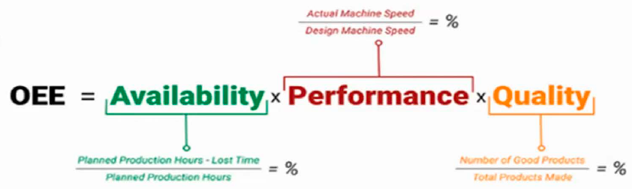

Typically, the world-class manufacturers are on 75-80%

* Safety stock = Maximum usage – Average usage
* Reorder point = Demand during lead time + Safety stock
* Economic Order Quantity (EOQ)

